

**ScanBee:**

**Automated Attendance Tracking System – High Level Use Case Document**

**Wenona Marie M. Montemayor**

**Neil Roy G. Omongos**

**Shamaiah Lee Cadut**

**BACHELOR OF SCIENCE IN INFORMATION TECHNOLOGY**

**MAY 2025**

**Overview**

This document outlines the primary interactions between different users and the system for an educational management platform. The main actors include Administrators, Instructors, and Students, each with specific roles and functionalities.

**HIGH LEVEL USE CASE DIAGRAM**

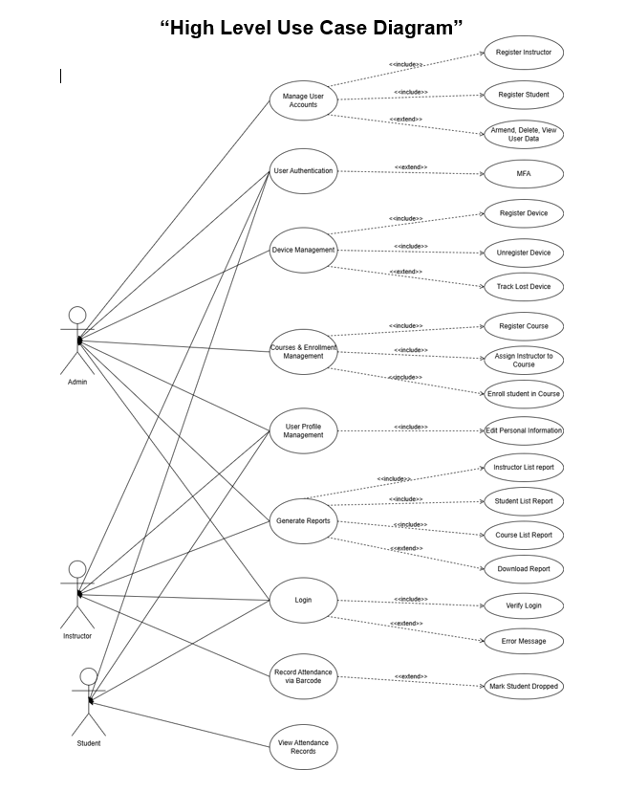

**Actors and Their Responsibilities**

**Admin**: Manages system-wide functions such as user accounts, device management, course management, and report generation.

**Instructor**: Manages courses, views reports, and assesses student attendance.

**Student**: Views attendance records and interacts with registration and profile management functionalities.

**Manage User Accounts**

**Actor**: Admin

**Description**: The admin can create, update, arm, disarm, delete, and view user data for instructors and students.

**Extensions**:

Register Instructor: Add a new instructor to the system.

Register Student: Add a new student to the system.

Delete, View User Data: Manage existing user profiles.

**User Authentication**

**Actor**: All users (Admin, Instructor, Student)

**Description**: Users authenticate themselves to access system features.

**Extensions**:

Multi-Factor Authentication (MFA): Adds an extra security step during login.

**Device Management**

**Actor**: Admin

**Description**: Allows the admin to register, unregister, and track lost devices linked to users.

**Extensions**:

Register Device: Add new device.

Unregister Device: Remove a device.

Track Lost Device: Manage lost devices for security purposes.

**Courses & Enrollment Management**

**Actor**: Admin

**Description**: Manage course creation, instructor assignment, and student enrollment.

**Extensions**:

Register Course: Create new courses.

Assign Instructor to Course: Link instructors to courses.

Enroll Student in Course: Add students to courses.

**User Profile Management**

**Actor**: Users (Admin, Instructor, Student)

**Description**: Allow users to view and edit their personal information.

**Generate Reports**

**Actor**: Users (Admin, Instructor, Student)

**Description**: Generate various reports related to users and courses.

**Extensions**:

Instructor List Report: View list of all instructors.

Student List Report: View list of all students.

Course List Report: View all available courses.

**Login**

**Actor**: All users

**Description**: Users logging into the system with credentials.

**Extensions**:

Verify Login: Authenticate user credentials.

Error Message: Handle failed login attempts.

**Record Attendance via Barcode**

**Actor**: Instructor or authorized personnel

**Description**: Mark student's attendance by scanning a barcode.

**Extensions**:

Mark Student Dropped: Mark students who have dropped the course during attendance.

**View Attendance Records**

**Actor**: Student

**Description**: Students can view their attendance history.

**SUMMARY**

This high-level use case diagram describes the main interactions within the system, highlighting key features such as user management, device handling, course management, report generation, attendance recording, and authentication processes. Each role has specific rights and functions aligned with its responsibilities within the platform.

Additionally, the system is designed to be scalable and adaptable, allowing for future feature enhancements and integration with other institutional systems. Its modular approach ensures that new functionalities can be added seamlessly, supporting evolving educational needs and technological advancements. This makes the platform a comprehensive solution for current administrative and instructional requirements and a flexible foundation for future growth.

Thank You & God Bless